FODS ASSIGNMENT 6

Name – Atharva Shivaji Dabkekar
Roll no. – 2090139
PRN - 1251090357
Division – S.Y A
Batch – 2
DATE – 18-08-2026 TIME – 8:00 TO 10:00
Question - Practical 6: Sorting Algorithms
Implement Bubble Sort, Selection Sort, Insertion Sort, Shell Sort, and Quick Sort. Analyse their best, average, and worst-case time complexities.
ANSWER:
- Bubble Sort :
CODE:
#include <iostream>
using namespace std;
int main() {
int n;
cout << "Enter number of elements: ";
cin >> n;
int arr[n];
cout << "Enter the elements: ";
for (int i = 0; i < n; i++) {
cin >> arr[i];
}
for (int i = 0; i < n - 1; i++) {
for (int j = 0; j < n - i - 1; j++) {
if (arr[j] > arr[j + 1]) {
int temp = arr[j];
arr[j] = arr[j + 1];
arr[j + 1] = temp;
}
}
}
cout << "Sorted array: ";
for (int i = 0; i < n; i++) {
cout << arr[i] << " ";
}
cout << endl;
return 0;
}

OUTPUT:
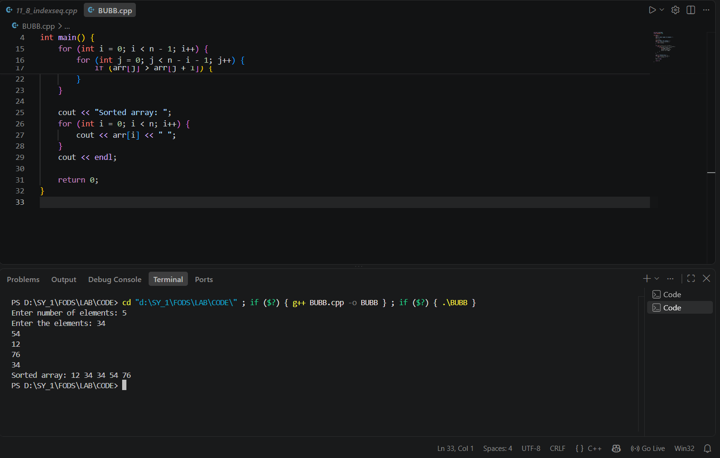

- Selection Sort:
Code:
#include <iostream>
using namespace std;
int main() {
int n;
cout << "Enter number of elements: ";
cin >> n;
int arr[n];
cout << "Enter the elements: ";
for (int i = 0; i < n; i++) {
cin >> arr[i];
}
for (int i = 0; i < n - 1; i++) {
int minIndex = i;
for (int j = i + 1; j < n; j++) {
if (arr[j] < arr[minIndex]) {
minIndex = j;
}
}
int temp = arr[i];
arr[i] = arr[minIndex];
arr[minIndex] = temp;
}
cout << "Sorted array: ";
for (int i = 0; i < n; i++) {
cout << arr[i] << " ";
}
cout << endl;
return 0;
}
Output:
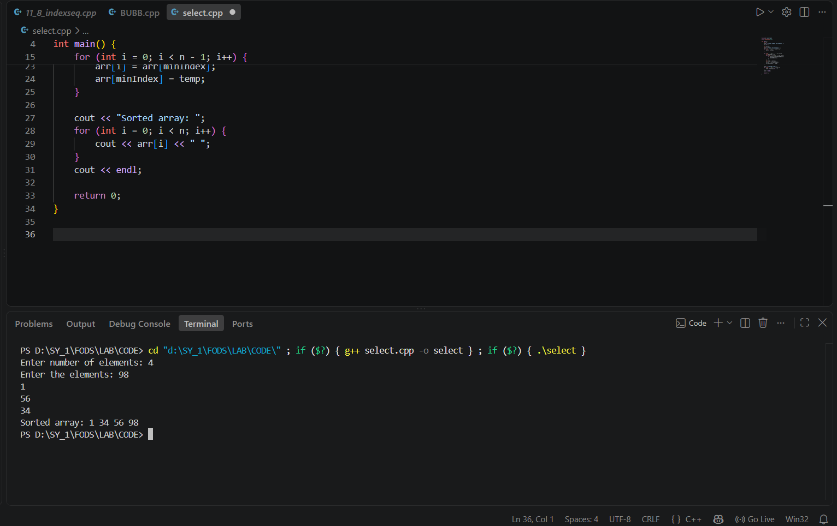
- Insertion Sort :
CODE:
#include <iostream>
using namespace std;
int main() {
int n;
cout << "Enter number of elements: ";
cin >> n;
int arr[n];
cout << "Enter the elements: ";
for (int i = 0; i < n; i++) {
cin >> arr[i];
}
for (int i = 1; i < n; i++) {
int key = arr[i];
int j = i - 1;
while (j >= 0 && arr[j] > key) {
arr[j + 1] = arr[j];
j--;
}
arr[j + 1] = key;
}
cout << "Sorted array: ";
for (int i = 0; i < n; i++) {
cout << arr[i] << " ";
}
cout << endl;
return 0;
}
OUTPUT:
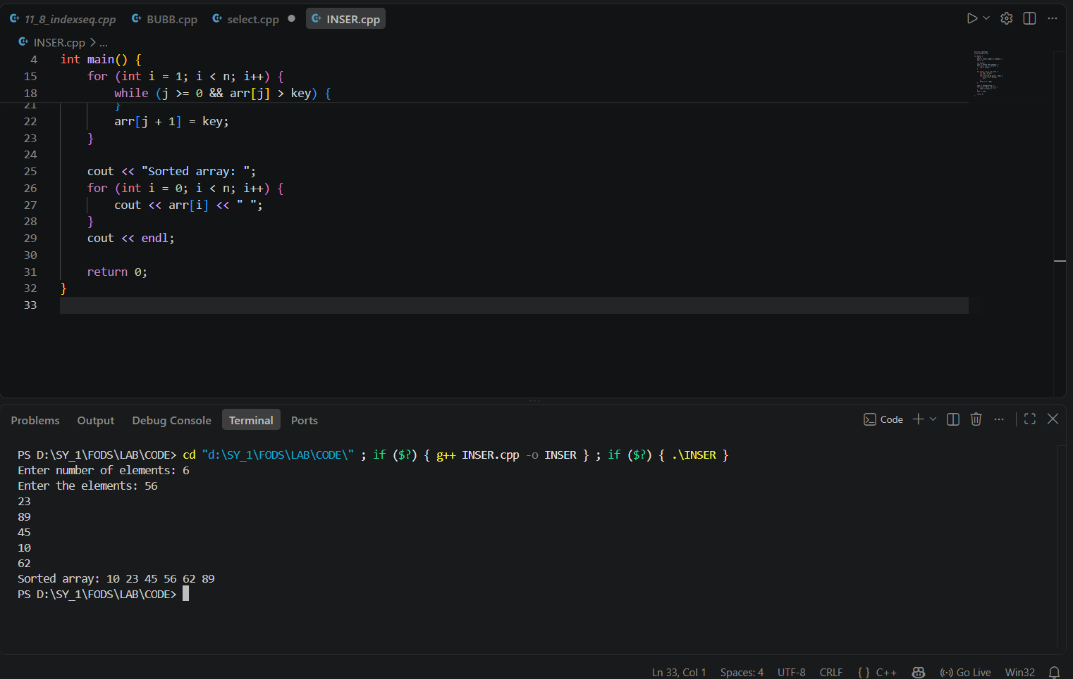

- Shell Sort:
CODE:
#include <iostream>
using namespace std;
int main() {
int n;
cout << "Enter number of elements: ";
cin >> n;
int arr[n];
cout << "Enter the elements: ";
for (int i = 0; i < n; i++) {
cin >> arr[i];
}
for (int gap = n / 2; gap > 0; gap /= 2) {
for (int i = gap; i < n; i++) {
int temp = arr[i];
int j = i;
while (j >= gap && arr[j - gap] > temp) {
arr[j] = arr[j - gap];
j -= gap;
}
arr[j] = temp;
}
}
cout << "Sorted array: ";
for (int i = 0; i < n; i++) {
cout << arr[i] << " ";
}
cout << endl;
return 0;
}

Output:
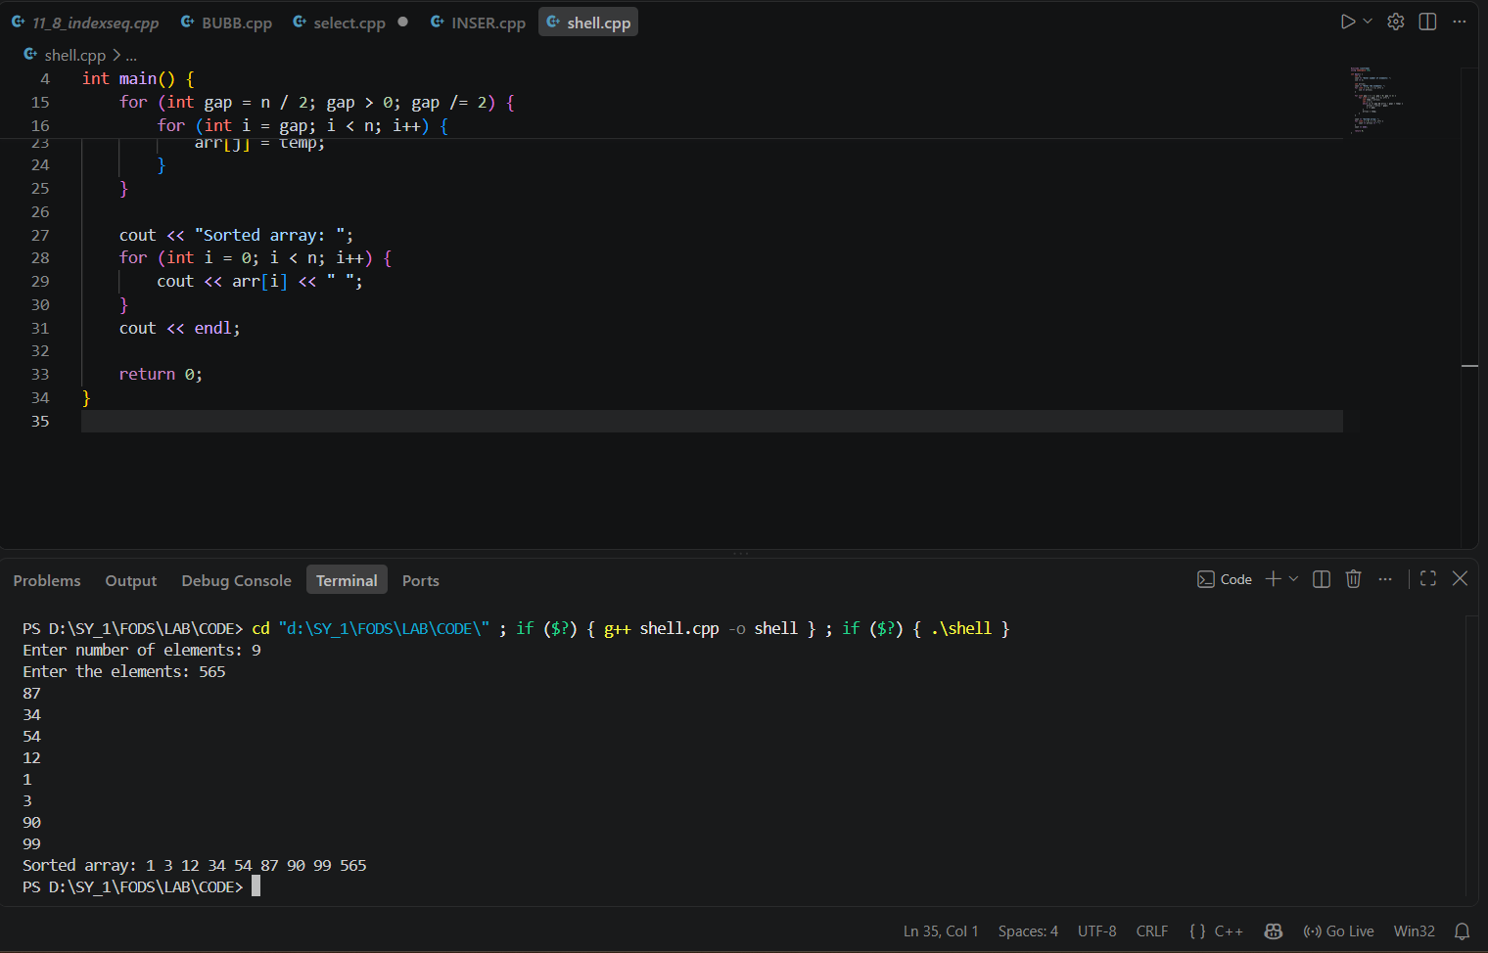

- Quick Sort :
CODE:
#include <iostream>
using namespace std;
int partition(int arr[], int low, int high) {
int pivot = arr[high];
int i = low - 1;
for (int j = low; j < high; j++) {
if (arr[j] < pivot) {
i++;
int temp = arr[i];
arr[i] = arr[j];
arr[j] = temp;
}
}
int temp = arr[i + 1];
arr[i + 1] = arr[high];
arr[high] = temp;
return i + 1;
}
void quickSort(int arr[], int low, int high) {
if (low < high) {
int pi = partition(arr, low, high);
quickSort(arr, low, pi - 1);
quickSort(arr, pi + 1, high);
}
}
int main() {
int n;
cout << "Enter number of elements: ";
cin >> n;
int arr[n];
cout << "Enter the elements: ";
for (int i = 0; i < n; i++) {
cin >> arr[i];
}
quickSort(arr, 0, n - 1);
cout << "Sorted array: ";
for (int i = 0; i < n; i++) {
cout << arr[i] << " ";
}
cout << endl;
return 0;
}
OUTPUT:
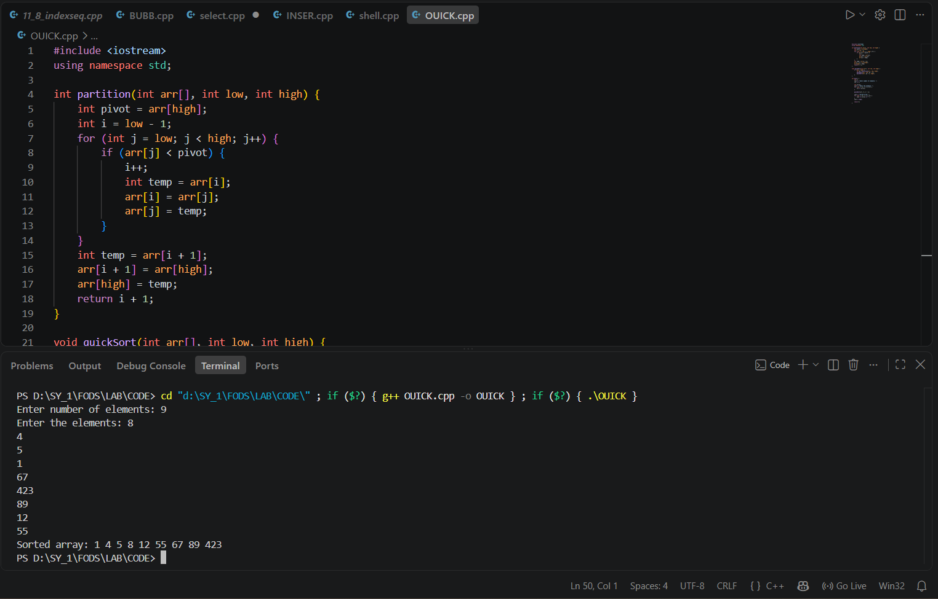

Comparison of Time Complexities:
Algorithm | Best-Case | Average-Case | Worst-Case
Bubble Sort | O(n) | O(n²) | O(n²)
Selection Sort | O(n²) | O(n²) | O(n²)
Insertion Sort | O(n) | O(n²) | O(n²)
Shell Sort | O(n log n) | O(n¹·³⁵) | O(n²)
Quick Sort | O(n log n) | O(n log n) | O(n²)

